Configuring Work Groups for CoreTime

These steps are followed by HR Systems when configuring new or existing work groups for use with CoreTime

Creating a New Work Group

- Login to CoreHR Back Office
- Navigate to CoreTime/CoreRoster > System Parameters > Work Groups
- Enter the Work Group Number as the next consecutive number available (6 digits) – run PERDEP16 to get a list of current workgroups
- Enter the Work Group Name based on the information submitted by the department in the OSM request (note all Work Group names should be unique and should begin with the two character department code)
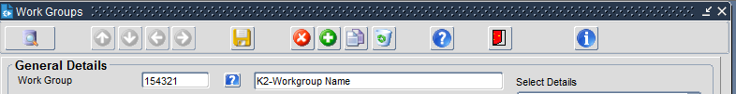

- Company, click the ‘?’ and select 1. University of Oxford
- Click on the yellow disc to Save the record.

Configuring a Work Group for use with CoreTime

- Login to CoreHR Back Office
- Navigate to CoreTime/CoreRoster > System Parameters > Work Groups
- Next to the Work Group field, click the ‘?’ to bring up a list of workgroups and select the work group you wish to configure
- Use the ‘?’ to select the relevant Holiday Scheme from the list.
- Add Default Shift Type of ‘REST’
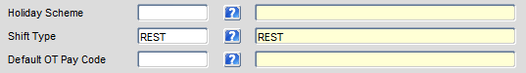
- In the ‘General Parameters – 1 > Payroll Interface section’
- Select the ‘Live Timesheets’ option
- Tick the ‘Generate Timesheets’ check box

In the Under the General Parameters – 1 > Pay Frequency section
- Set the Frequency field to ‘Monthly UDC’

All other fields in this section should be left/set to the default blank values
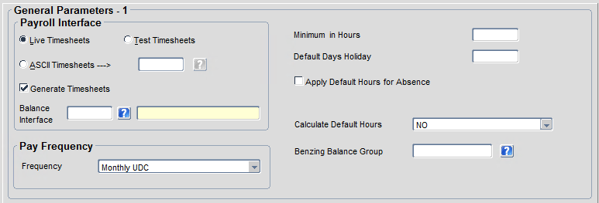

- Under the ‘Select Details’ list, select ‘General Parameters – 2’
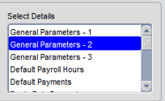

- Within the General Parameters -2 Section
- Tick the ‘Calculate Clockings’ check box
- Tick the ‘Allow Generation of Default Clocks’ check box
- Tick the ‘User Defined Calendar Group’ check box
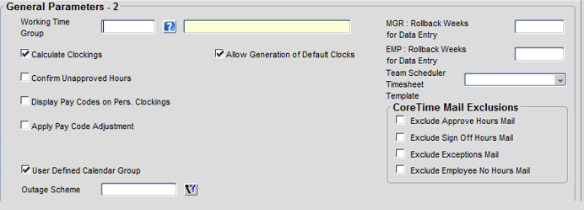

- Under the ‘Select Details’ list, select ‘Group Codes’
Note: you will need to scroll down through the list
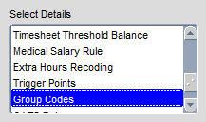

- Under the Group Codes’ section
Click on the ‘?’ next to ‘Personalised Pay Code Group’ and select ‘Manager’ from the drop down
